1.To Apply Single Quotes, Preserve Literal Content, Ignore Variable Expansion, Store Quoted Strings, Validate Parsing Results, Test Edge Cases
2.To Apply Double Quotes, Preserve Spaces, Allow Variable Expansion, Parse Nested Tokens, Validate Outputs, Test Quoted Commands
Code:
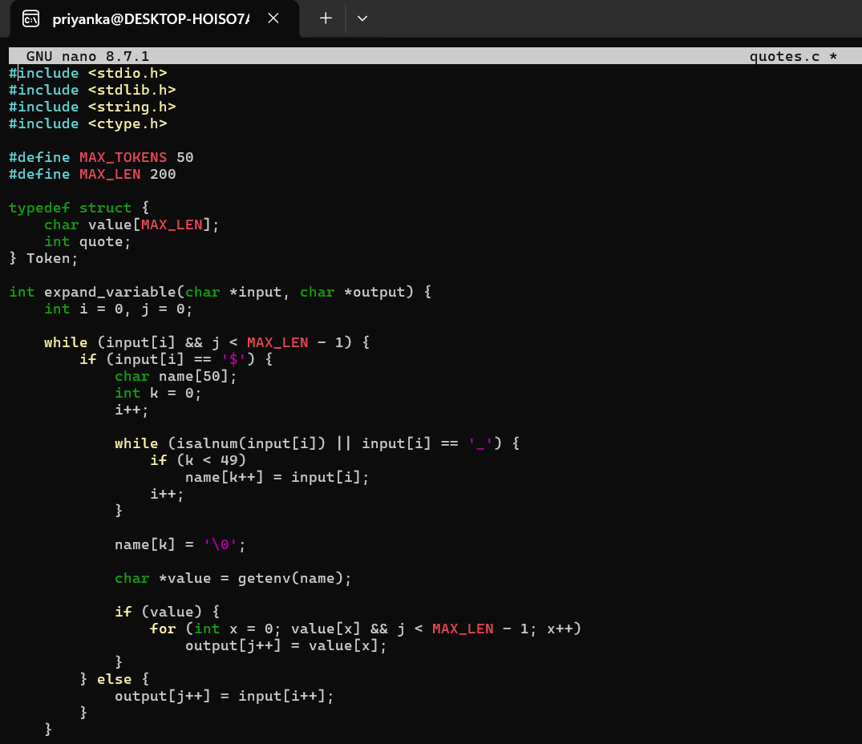
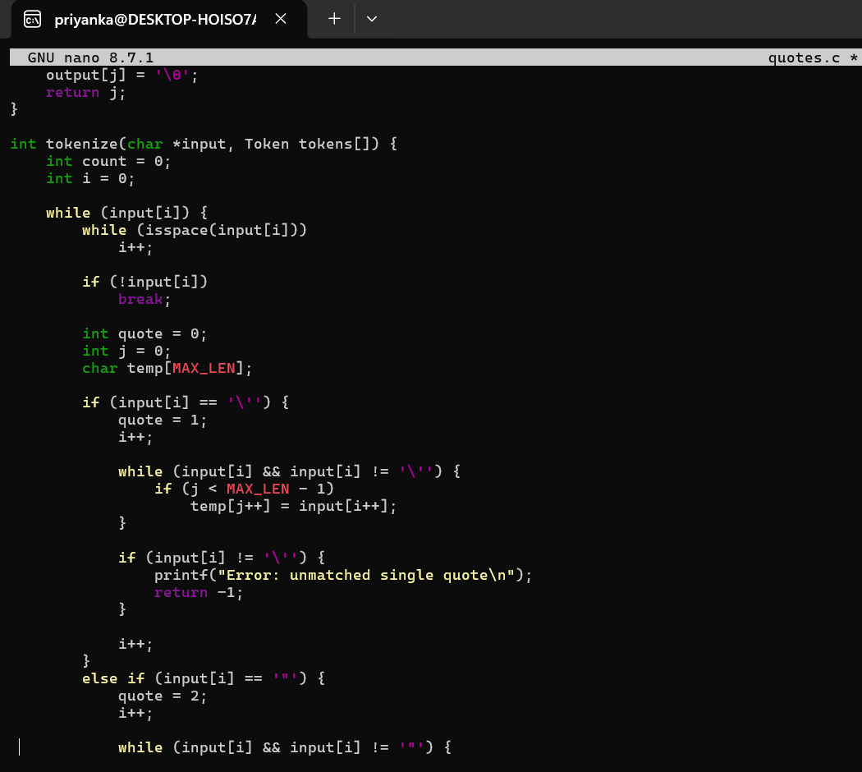
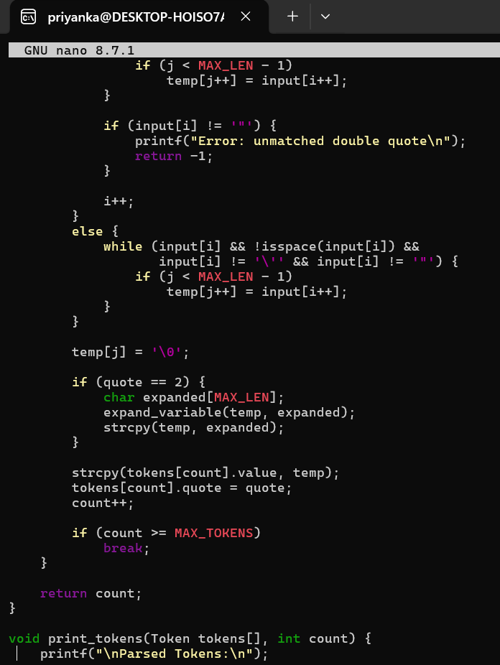
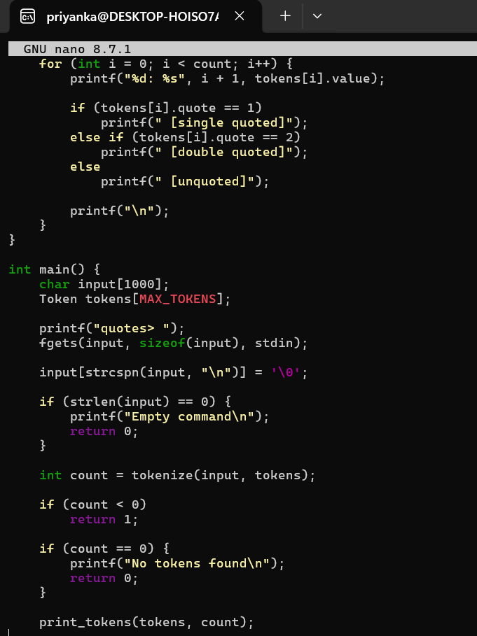
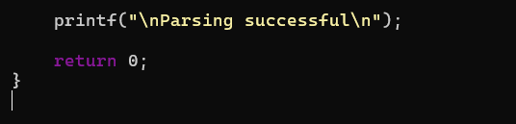
Output:
